SPREE Experiment
Writing The RT-130 Configuration From Scratch

1. Find the PFC_130 application in the Launcher and tap on it to start the application. A startup splash screen will appear for a couple of seconds.

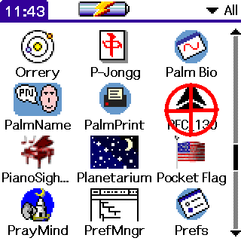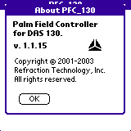

2. Select Work with Configuration. When the Configuration Manager form appears tap the New button.

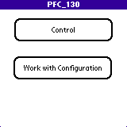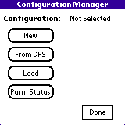

3. Enter a name for the configuration in the New Configuration dialog box ("SPREE in this example) and tap the OK button. This entry will show up later when it is time to save the configuration.
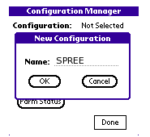
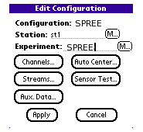
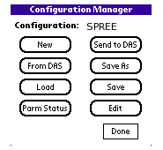
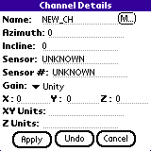
4. When the Configuration Manager form returns it will have four more buttons. Tap the Edit button to bring up the Edit Configuration form. On the Edit Configuration form you can enter information about an individual station and the experiment. "st1" and "SPREE" have been entered for the Station and the Experiment name in the example below. When finished tap the Channels... button.

5. On the Channels form make sure the channel 1 line is selected (so that it has the box around it) and tap the Activate button.

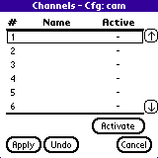

6. Change the Name, Sensor (type), and Sensor# to the desired values. Tap on the down arrow to the left of the Gain label and select the Unity setting from the popup menu if the Gain is not already set to Unity. When finished tap the Apply button to return to the Channels form.
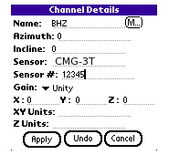
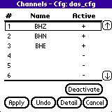
7. Repeat selecting, setting the gain, Name, Sensor, and Sensor# and applying the changes for channels 2 and 3.
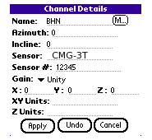
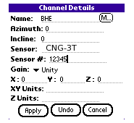

8. Tap the Apply button on the Channels form when finished editing the channel information. Back on the Edit Configuration form tap the Streams... button.

9. The Streams form works in a similar manner as the Channels form did. Activate stream 1 by tapping on the checkbox on line 1 that is below the letter "D" (These checkboxes designate where the data should be sent: D is for DAS/Disk, E is for Ethernet, and S is for serial port output). The application will fill in the name NEW_STREAM, and fill in a default sample rate, data format and trigger type. To change these tap the Detail button.

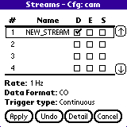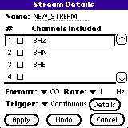
10. On the Stream Details form select the checkbox for channels 1, 2, and 3, and fill in the stream Name as desired. For data stream 1 a Format of CO (compressed) is OK, and a Trigger setting of Continuous is also OK. Tap on the Details button and set the Record Length to 21600 on the Continuous Trigger dialog box. A future start time can also be set on this dialog box if needed, but it is usually left alone. Tap OK to return to the Stream Details display. The default Rate of 1 Hz is OK. Tap OK, then Apply on the Stream Details form to return to the Streams form.

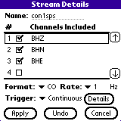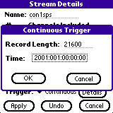

11. Repeat for data stream 2, except set the Record Length to 3600 and set the Rate to 40 Hz. Tap Apply on the Stream Details form when finished. Tap Apply on the Streams form when you are finished with that form.

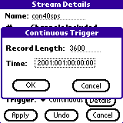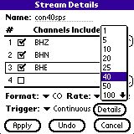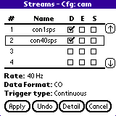

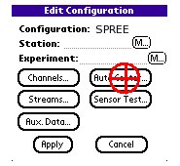
12. On the Edit Configuration form tap the Auto Center... button.
13. Tap on the down arrow to the right of the Enable label and select ON. Enter the number "5" in the field to the right of the Cycle Time label. This means that the RT-130 will send an auto-centering pulse to the attached sensor every 5 DAYS (not Hrs as is indicated on the form). None of the other settings function. Tap the Apply button to return.

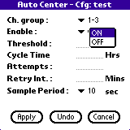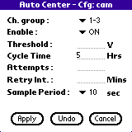

14. Edit the Sensor Calibration Parameters
Tap on “Sensor Test” (Work with Configuration -> Edit -> Sensor Test”
For a Guralp - 3T – enter/select these values:
Ch. group: 1-3
Enable: ON
Signal Type: Step
Amplitude: 0.5 (volts clie has max output of 3.75V)
Duration: 1000 (seconds 15 min is 900 sec)
RefTek manual says that the duration range is 1 -500
Pulse Width: 300 (seconds)
Pulse Interval 600(seconds)
Tap “apply”.
NOTE : to actually carry out the calibration:
use Control -> Aux. Control. -> Test 1-3)
switch mass on GCU every 5 minutes

15. Tap the Apply button on the Edit Configuration form to return to the Configuration Manager form. Tap the Save button to save the configuration settings using the configuration name that you entered back in Step 3. Click the Done button to return to the main menu.

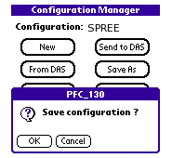

16. SEND THE PARAMETERS TO THE DAS.
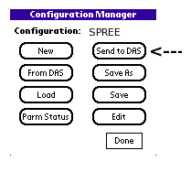
17. The entered configuration will remain in use and available for sending to the RT-130s as long as you do not leave the PFC_130 application. If you leave the application you must select the Work with Configuration item and Load the desired configuration settings from the Load Configuration menu that will appear.



